CPU simulation background information
This document contains some information for understanding the Logisim Evolution CPU simulation, which is also given in a video. There will also be an overview in the lecture in week 6. Note that the CPU simulation aims to demonstrate some of the fundamental principles of computers and how a programmable computer can be created from simple components. There are, however, simplifications made in the CPU simulation used in this coursework.

Registers and Memory
The CPU simulation has two registers, the program counter (PC) and the accumulator (ACC). The program counter gives the address of the instruction that is to be run the next time the clock changes to 1. See week 5 lab B for registers.
The ALU always takes one input from the accumulator and the other input according to the instruction given in the program. The output from the ALU always goes to the accumulator. See week 4 lab A for ALU.
The CPU simulation has separate storage for programs and data. Each item in the data memory is 8 bits (2 hex digits) and so can hold numbers from 0 to 255 when using unsigned integers, or -128 to 127 with signed integers. The address for the data memory is 8 bits (so can store 256 items of data with addresses from 00 to ff). See week 6 lab A for memory.
To run the simulation, a program has to be loaded into the instruction memory. Each instruction in the instruction memory is 16 bits (4 hex digits) and this memory also has an 8-bit address like the data memory (so can store 256 items). See week 6 lab B for a simulation with similar features to this one.

Instruction format
A program is a list of instructions. For this CPU simulation, each instruction consists of 16 bits (i.e., two bytes) which we view and amend as four hex digits. The hex digits have different purposes, the first digit (bits 12-15) is the CPU operation, the second hex digit (bits 8-11) is the ALU operation, and the last two digits (bits 0-7) form an address (to be used for the data memory or later the instruction memory) or immediate value to be used directly in a calculation. The selection between immediate value or memory value is done using a multiplexer. See week 3 lab B for multiplexers. In the circuit, the instruction is split in the Instruction Decoding unit. See week 4 lab B for a decoder and week 2 lab B for splitters.

The instruction structure, and the relation to hex digits is summarised in the table below. The top row shows the position of the binary digits. Note that when giving bit numbers the convention is that the least significant bit is numbered 0.
15 | 14 | 13 | 12 | 11 | 10 | 9 | 8 | 7 | 6 | 5 | 4 | 3 | 2 | 1 | 0
CPU operation |  |  |  | ALU Operation |  |  |  | Address or immediate value
Hex digit |  |  |  | Hex digit |  |  |  | Hex digit |  |  |  | Hex digit

The CPU operations are as follows:
0 no operation
1 Immediate value from instruction becomes the second input to ALU (Input2)
2 Value read from data memory at the address given in the instruction becomes Input2
3 copy value from accumulator (ACC) to data memory at address given in instruction
4 branch (set the program counter) to address given in instruction when ACC value is not equal to zero
5 output character to console (TTY) by treating the value in ACC as an ASCII value
6 clear the TTY
7 stop until an input from the player is received
f stop
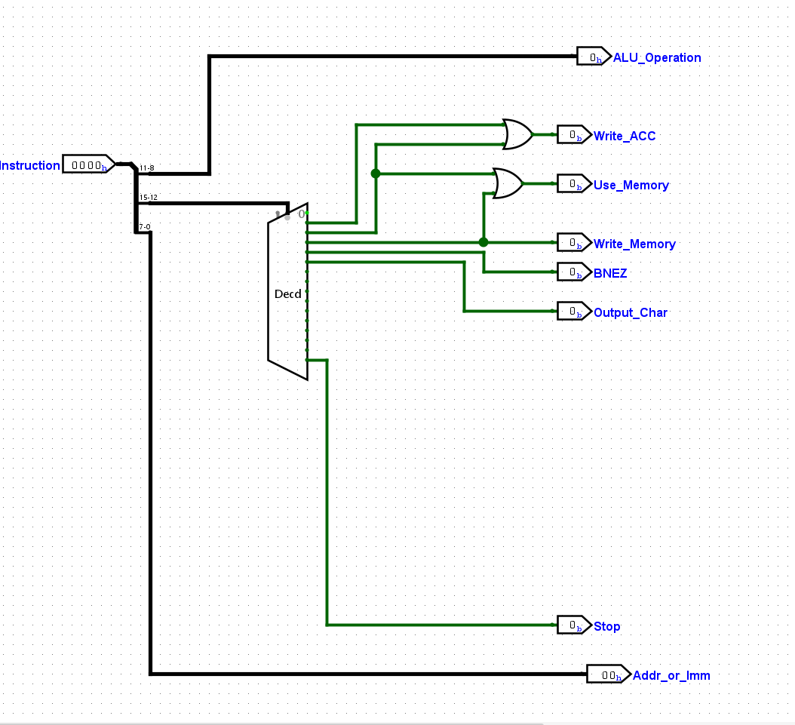
Note that CPU operations 4, 5 and f do not work in the starter CPU circuit provided (they should be completed as tasks). For the highest marks, you should add more CPU operations as hex digits 5 to e do not have an operation assigned.

The ALU operations are as follows:
0 pass Input2 to the ACC unchanged
1 add the two inputs
2 bitwise NAND of the two inputs
3 bitwise OR of the two inputs
4 right-shift by 4 bits of input from the ACC
5 set greater than: set the accumulator to 1 when input 1 (previous ACC value) is greater than input 2; otherwise set the ACC to 0
6 convert the value in the ACC to the ascii equivalent of it. Input 2 will tell which nibble will be used
7 generates a random 8 bit number
8 Set the ACC to the button type pressed 01 = greater than button 00 = less than or equal to button
9 checks if the value in the alu is equal to the input 2
10 divides the value in the alu by input2 and outputs the DIV
11 divides the value in the alu by input2 and outputs the MOD

Note that ALU operations 4 and 5 do not work in the starter circuit provided (they should be completed as tasks). Again, you would need to add operations for the highest marks.

Understanding the first program
The program (program1.dat) provided for this task is as follows:
v2.0 raw
102b 3000 # 1. put first value to ACC and address 00
1015 3001 # 2. put second value to ACC and address 01
2100 # 3. add ACC value to value from address 00
3002 # 4. store ACC value at address 02
f000 # 5. stop

The first instruction, 102b, overwrites the ACC with the hex value 2b. This is because CPU operation 1 indicates that an immediate value (2b in this case) should be used as Input2 and ALU operation 0 passes Input2 to the ACC.

The instruction 3000 starts with a 3 which indicates that the value from the ACC should be copied to the data memory at the address given by the last two digits in the instruction (in this case 00). The following two instructions follow the same pattern but write the value to address 01 in data memory.

The instruction 2100 starts with 2 so the value read from data memory at the address given in the instruction (in this case 00) becomes Input2. The second digit (1 in this case) is the ALU operation of addition. The values from the ACC and Input2 will be added together and the result overwrite the ACC value.
The instruction 3002 follows the same pattern as the other instructions starting with a 3.

The instruction f000 should stop the program but does not work initially and should be completed in a later task.

